**Angina/Stable/Typical Angina & Unstable/Atypical Angina**

**Overview**

Angina is a type of chest pain caused by reduced blood flow to the heart. It is a symptom of coronary artery disease. Angina, which may also be called angina pectoris or typical angina, is often described as squeezing, pressure, heaviness, tightness or pain in your chest. Some people with angina symptoms describe angina as feeling like a vise is squeezing their chest or feeling like a heavy weight has been placed on their chest. Angina may be a new pain that needs evaluation by a doctor, or recurring pain that goes away with treatment. Although angina is relatively common, it can still be hard to distinguish from other types of chest pain, such as the pain or discomfort of indigestion.

**Symptoms**

* Chest pain or discomfort, possibly described as pressure, squeezing, burning or fullness
* Pain in your arms, neck, jaw, shoulder or back accompanying chest pain
* Nausea
* Fatigue
* Shortness of breath
* Sweating
* Dizziness

These symptoms need to be evaluated immediately by a doctor who can determine whether you have stable angina, or unstable angina that may indicate a possible heart attack. **Stable angina** is the most common form of angina. It usually happens when you exert yourself and goes away with rest. For example, pain that comes on when you're walking uphill or in the cold weather is often angina.

**Characteristics of stable angina**

* Develops when your heart works harder, such as when you exercise or climb stairs
* Can usually be predicted and the pain is usually similar to previous types of chest pain you've had
* Lasts a short time, perhaps five minutes or less
* Disappears sooner if you rest or use your angina medication

The severity, duration and type of angina can vary. New or different symptoms may signal a more dangerous form of **angina (unstable angina) or atypical angina or a heart attack**.

**Characteristics of unstable angina (a medical emergency or might signal a heart attack)**

* Occurs even at rest
* Is a change in your usual pattern of angina
* Is unexpected
* Is usually more severe and lasts longer than stable angina, maybe 30 minutes or longer
* May not disappear with rest or use of angina medication

There's another type of angina, called **variant angina or Prinzmetal's angina**. This type of angina is rarer. It's caused by a spasm (*a sudden involuntary muscular contraction*) in your heart's arteries that temporarily reduces blood flow.

**Characteristics of variant angina (Prinzmetal's angina)**

* Usually happens when you're resting
* Is often severe
* May be relieved by angina medication

Men commonly have the usual kind of angina as described above.

**Angina in women**

A woman's angina symptoms can be different from the classic angina symptoms. These differences may lead to delays in seeking treatment. For example, chest pain is a common symptom in women with angina, but it may not be the only symptom or the most prevalent symptom for women. Women may also experience symptoms such as:

* Nausea
* Shortness of breath
* Abdominal pain
* Discomfort in the neck, jaw or back
* Stabbing pain instead of chest pressure

Women may have more of a subtle (*delicate or precise as to be difficult to analyze or describe*) presentation called **atypical angina**. For example, in one study of over 500 women who suffered a heart attack, 71% had fatigue, 48% had sleep disturbances, 42% had shortness of breath, and 30% had chest discomfort in the month prior to the heart attack. At the time of their heart attack, 58% had shortness of breath, 55% had weakness, 43% had fatigue, and 43% had chest discomfort. The problem may present like an indigestion feeling and can even mimic a problem related to peptic ulcer disease or gallbladder disease.

**Non-anginal chest pain**

The term "atypical chest pain" is a waste-basket term that leads physicians to send any patient with chest pain to coronary angiography. In order to avoid this term, we must learn to distinguish atypical angina from non-anginal chest pain before angiography is considered in order to avoid unnecessary invasive procedures.

A chest pain is very likely non-anginal if its duration is very less (e.g. less than 5 seconds or few minutes), it increases with inspiration, can be brought on with one movement of the trunk or arm (*The* ***head*** *is attached to the* ***trunk*** *by the neck. - The* ***trunk*** *includes the chest, the back, the shoulders and the abdomen.*), can be brought on by local fingers pressure, or bending forward, or it can be relieved immediately on lying down.

**Asymptomatic chest pain**

**Asymptomatic** means neither causing nor exhibiting symptoms of disease.

**Symptomatic** means a physical indication (rash, pain, discomfort etc.) of disease or disorder. For example, red spots are symptomatic of measles and chest pain is symptomatic of a heart attack (myocardial infarction).

**Note**: Do not confuse "**symptomatic**" with the term **systemic**, which means spread throughout the body *(Systemic means affecting all body systems and organs rather than being localized in one area or organ. Systemic can refer to a disease, symptom, medication or injury. For example, a bad case of the flu (influenza) affects your entire body.)*.

***SDS Relevance***

A safety data sheet (SDS), material safety data sheet (MSDS), or product safety data sheet (PSDS) are documents that list information relating to occupational safety and health for the use of various substances and products.

"**Asymptomatic**" usually appears on an SDS in the context of an exposure to the material not causing any obvious symptoms even though it presents a health hazard. This is why it is always important to read and understand SDS's before working with workplace substances.

"**Symptomatic**" usually appears in reference to the recommended treatment for exposure to the material. For example, the SDS may say to treat the effects by treating the symptoms it causes (e.g. "treat symptomatically"). That means while you can't treat the exposure directly, you can mitigate its effects by giving ibuprofen for pain (*Ibuprofen is a medication in the nonsteroidal anti-inflammatory drug class that is used for treating pain, fever, and inflammation*), oxygen for breathing difficulty etc.

When reading and understanding SDS's, be sure to take in the Big Picture. Many different processes can cause the same set of symptoms. For example, chest pain is symptomatic of a heart attack, but it also indicates a bad case of heart burn. Just because you are showing symptoms of exposure to a material, do not immediately rule out other likely causes.

**Cholesterol and Serum cholesterol**

**Cholesterol** is a type of body fat, or lipid. **Cholesterol** is a waxy, fatty substance. Some cells in the liver produce it and release it into the bloodstream. A **serum cholesterol level** is a measurement of certain elements in the blood, including the amount of high & low density lipoprotein cholesterol (HDL and LDL) in a person's blood.

**Serum cholesterol** levels also show the amount of triglycerides present. Triglycerides are another lipid that can be measured in the blood.

According to the American Heart Association, low-density lipoprotein (LDL) cholesterol is often considered bad, while high-density lipoprotein (HDL) cholesterol is considered good. A person's serum cholesterol level can indicate their risk for conditions such as heart disease.

**LDL cholesterol** can build up in a person's arteries, clogging them and reducing blood flow. This is why cholesterol is often linked to heart disease. Whereas, **HDL cholesterol** helps to mop up other cholesterol in the blood and unstick it from artery walls. This is why HDL cholesterol is considered good.

With a blood test, a doctor can measure levels of:

* **HDL cholesterol**, which is good
* **LDL cholesterol**, which is bad
* **Triglycerides**, which are a type of fat bundled with cholesterol

Total **serum cholesterol** is calculated by adding the HDL level, the LDL level, and 20 percent of the triglyceride level present in a blood sample.

**Blood Sugar or Glucose**

Over time, high blood glucose from diabetes can damage your blood vessels and the nerves that control your heart and blood vessels. People with diabetes tend to develop heart disease at a younger age than people without diabetes. In adults with diabetes, the most common causes of death are heart disease and stroke.

**Resting electrocardiography**

Resting 12-lead electrocardiography (ECG) is a non-invasive test that can detect abnormalities including arrhythmias, evidence of coronary heart disease, left ventricular hypertrophy and bundle branch blocks.

In the preoperative setting, resting ECG is used to assess known cardiovascular diseases, to detect previously undiagnosed cardiovascular diseases, and to provide a baseline standard against which to measure changes in the postoperative period.

In some instances, T wave changes might suggest specific conditions, such as peaked T waves in hyperkalemia or symmetric T wave inversions during myocardial ischemia. But what about all the other T wave abnormalities, such as flat T waves, biphasic T waves or asymmetric T wave inversions?

Similarly, ST segment abnormalities on the ECG can sometimes be due to a specific cause, such as ST segment elevation myocardial infarction, pericarditis or myocardial ischemia. Other times, there are just subtle abnormalities.

**Maximum heart rate achieved**

The maximum rate is based on your age, as subtracted from 220. So for a 50-year-old, maximum heart rate is 220 minus 50, or 170 beats per minute. At a 50 percent exertion level, your target would be 50 percent of that maximum, or 85 beats per minute.

**Oldpeak**

ST depression refers to a finding on an electrocardiogram, wherein the trace in the ST segment is abnormally low below the baseline. ST segment depression may be determined by measuring the vertical distance between the patient's trace and the isoelectric line at a location 2-3 millimeters from the QRS complex.

It is significant if it is more than 1 mm in V5-V6, or 1.5 mm in AVF or III.

In a cardiac stress test, an ST depression of at least 1 mm after adenosine administration indicates a reversible ischemia, while an exercise stress test requires an ST depression of at least 2 mm to significantly indicate reversible ischemia.

**CA – Fluoroscopy Procedure**

**What is fluoroscopy?**

Fluoroscopy is a study of moving body structures. It’s much like an X-ray "movie" and is often done while a contrast dye moves through the part of the body being examined. A continuous X-ray beam is passed through the body part and sent to a video monitor so that the body part and its motion can be seen in detail. Fluoroscopy, as an imaging tool, allows healthcare providers to look at many body systems, including the skeletal, digestive, urinary, cardiovascular, respiratory, and reproductive systems.

**Cardiac catheterization**. In cardiac catheterization, fluoroscopy is used to help the healthcare provider see the flow of blood through the coronary arteries to check for arterial blockages. Veins (Vessels) can be categorized into four main types**: pulmonary, systemic, superficial, and deep veins.**

**Slope of the peak exercise ST segment**

The treadmill electrocardiogram (ECG) stress test is widely used to screen for obstructive coronary artery disease (CAD). The presence of STsegment changes, either depression or elevation, on the ECG during the treadmill test often suggests presence of CAD and warrants further management.

Up-sloping ST-segment depression has not been historically considered as representing ischemia as this electrocardiographic change can be seen in normal subjects during exercise stress testing or tachycardia.

**ST segment**

In electrocardiography, the ST segment connects the QRS complex and the T wave and has a duration of 0.005 to 0.150 sec (5 to 150 ms).

It starts at the J point (junction between the QRS complex and ST segment) and ends at the beginning of the T wave. However, since it is usually difficult to determine exactly where the ST segment ends and the T wave begins, the relationship between the ST segment and T wave should be examined together. The typical ST segment duration is usually around 0.08 sec (80 ms). The ST segment represents the isoelectric period when the ventricles are in between depolarization and repolarization.

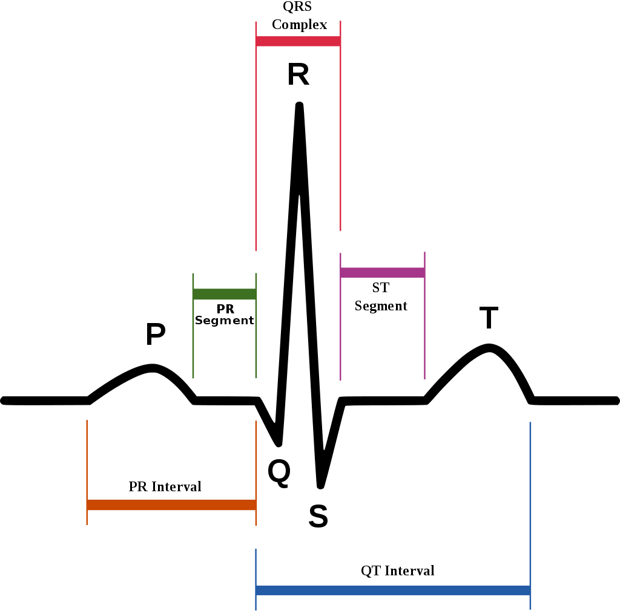

**Interpretation**

* The normal ST segment has a slight upward concavity.
* Flat, downsloping, or depressed ST segments may **indicate coronary ischemia**.

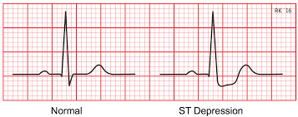 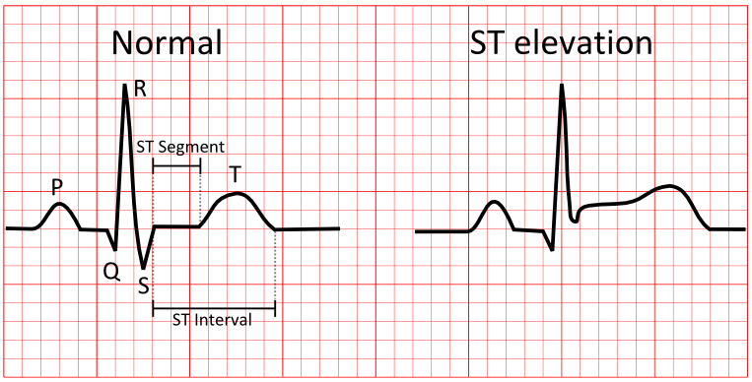

**Thal – Thalassemia**

Thalassemia is an inherited blood disorder that causes your body to have less hemoglobin than normal. Hemoglobin enables red blood cells to carry oxygen. If you have mild thalassemia, you might not need treatment. But more severe forms might require regular blood transfusions.

**Symptoms**

* Fatigue
* Weakness
* Pale or yellowish skin
* Facial bone deformities
* Slow growth
* Abdominal swelling
* Dark urine

**Causes**

Thalassemia is caused by mutations in the DNA of cells that make hemoglobin — the substance in red blood cells that carries oxygen throughout your body. The mutations associated with thalassemia are passed from parents to children.

Hemoglobin molecules are made of chains called alpha and beta chains that can be affected by mutations. In thalassemia, the production of either the alpha or beta chains are reduced, resulting in either alpha-thalassemia or beta-thalassemia.

**In alpha-thalassemia**, the severity of thalassemia you have depends on the number of gene mutations you inherit from your parents. The more mutated genes, the more severe your thalassemia.

**In beta-thalassemia**, the severity of thalassemia you have depends on which part of the hemoglobin molecule is affected.

**Risk factors**

In cases of severe thalassemia, the following complications can occurs:

* Bone deformities
* Enlarged spleen
* Slowed growth rates: Anemia can both slow a child's growth and delay puberty.
* **Heart problems**: Congestive heart failure and abnormal heart rhythms can be associated with severe thalassemia

**Reference Links**

1. <https://www.medicalnewstoday.com/articles/321519.php>
2. <https://www.ncbi.nlm.nih.gov/books/NBK367910/>
3. <https://www.mayoclinic.org/diseases-conditions/angina/symptoms-causes/syc-20369373>
4. <https://www.healio.com/cardiology/learn-the-heart/blogs/68-causes-of-t-wave-st-segment-abnormalities>
5. <https://www.ncbi.nlm.nih.gov/pmc/articles/PMC4958709/>
6. <https://www.ncbi.nlm.nih.gov/pmc/articles/PMC5295568/>
7. <https://en.m.wikipedia.org/wiki/ST_segment>
8. <https://www.cvphysiology.com/CAD/CAD012>
9. <https://www.urmc.rochester.edu/encyclopedia/content.aspx?ContentTypeID=92&ContentID=p07662>
10. <https://www.mayoclinic.org/diseases-conditions/thalassemia/symptoms-causes/syc-20354995>